Practice Assignment 3 Solutions
Bayesian Methods and Modeling
  - Discussion on Monday, May 11th at 4 PM

- Suppose we have a data set with each observation $x_{i}$ is independent and identically exponentially distributed for$i=1,2,…,n$. That is, $x_{i}∼Exp(λ)$ where $λ$ is the rate parameter. We would like to find a posterior (or at least a function proportional to it) for $λ$.
  - Write down the likelihood function in this situation. We would call this $p(x|λ)$.
The likelihood is found by multiplying the probability functions together. For an exponential, $p\left(x_{i} | λ\right)=λe^{-λx_{i}}$. So
$p\left(x | λ\right)=λe^{-λx_{1}}×λe^{-λx_{2}}×…×λe^{-λx_{n}}=λ^{n}e^{-λx_{1}-λx_{2}-…-λx_{n}}=λ^{n}e^{-λ\sum_{i=1}^{n}{x_{i}}}$.
Therefore, the likelihood function is.
$$p\left(x | λ\right)=λ^{n}e^{-λ\sum_{i=1}^{n}{x_{i}}}$$
  - Now let $λ$ have a normal prior with mean 0.1 and variance 1: $λ∼N(0.1, 1$). Use this and the likelihood from part (a) to write down a function that is proportional to the posterior of $λ$ given $x$. We call this $p(λ|x)$. Remember that any term without $λ$ that is being multiplied can be ignored.
The prior can be written $p\left(λ\right)=\frac{1}{\sqrt{2π⋅1^{2}}}e^{-\frac{1}{2⋅1^{2}}{\left(λ-0.1\right)}^{2}}$
Then the posterior is
$$p\left(λ | x\right)∝p\left(x | λ\right)⋅p\left(λ\right) \\ =λ^{n}e^{-λ\sum_{i=1}^{n}{x_{i}}}⋅\frac{1}{\sqrt{2π⋅1^{2}}}e^{-\frac{1}{2⋅1^{2}}{\left(λ-0.1\right)}^{2}} \\ =λ^{n}⋅\frac{1}{\sqrt{2π⋅1^{2}}}e^{-λ\sum_{i=1}^{n}{x_{i}}-\frac{1}{2⋅1^{2}}{\left(λ-0.1\right)}^{2}} \\ ∝λ^{n}⋅e^{-λ\sum_{i=1}^{n}{x_{i}}-\frac{1}{2⋅1^{2}}{\left(λ-0.1\right)}^{2}}$$
Written a little nicer, it would be
$$p\left(λ | x\right)∝λ^{n}\exp\left(-λ\sum_{i=1}^{n}{x_{i}}-\frac{1}{2⋅1^{2}}{\left(λ-0.1\right)}^{2}\right)$$

- Recall the Country_Information.csv dataset in the Practice 1 folder on GitHub. In this dataset, some variables were collected from 41 countries around the world. The variables in the dataset are
- Life expectancy (LifeExpectancy),
- Average number of years of schooling (YearsSchool),
- Gross domestic product per capita (GDP) in U.S. dollars,
- The gender inequality index (GII), which rates the amount of gender inequality in the given country (bigger values mean more inequality),
- An index score rating the quality of education in the given country (EduIndex), and
- Public health expenditures, which measures how much the given country spends on public health programs (PubHealthExp).

  - Read the dataset into R. Also, if you have not already, install the math3150package library from my GitHub (instructions for this are in the notes) and load that package. This will also load the tidyverse.
Done!
  - Fit a linear regression model using GII as the explanatory variable and life expectancy as the response variable like you did in the Practice 1 assignment. Write down the model in the context of the problem.
$$\hat{Life Expectency}=83.959-32.863(GII)$$
  - Now use the brm() function in the brms R package to fit a Bayesian model predicting life expectancy using GII. Use the default priors and the "cmdstanr" backend. Write down the model using the Estimate values.
This is based on random sampling, so your numbers might be a little different. But here were my values:
$$\hat{Life Expectency}=84.15-32.89(GII)$$

  - Compare the model estimates of the intercept, slope, and sigma value for the linear regression model fit in part (b) and the Bayesian model fit in part (c). How similar or different are the values?
The values are very similar. The intercept changed from 83.959 to 84.15, the slope went from 32.863 to 32.89, and sigma (the residual standard error) changed from 5.769 to 5.85. Again, your values may be slightly different.
  - Compare the standard error and estimated errors for the intercept and slope for the linear regression and Bayesian models. How similar or different are the values?
The standard errors for the intercept and slope in the linear regression model were 1.634 and 4.334, respectively.
The estimated errors for the intercept and slope in the Bayesian model were 1.60 and 4.39, respectively.
Again, these values are very close.
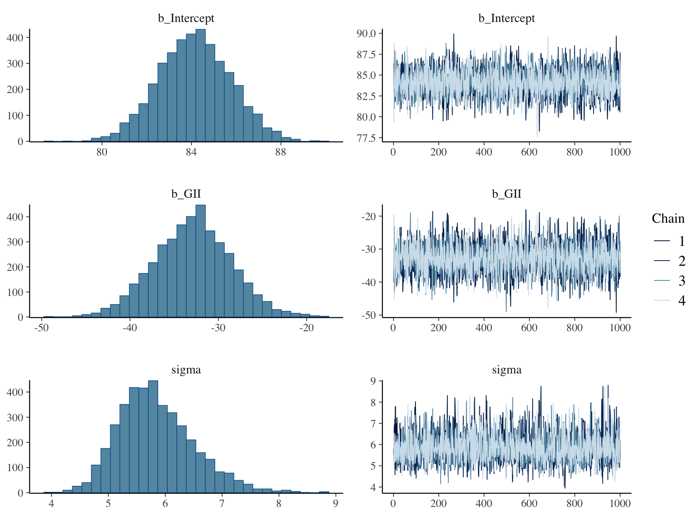
  - Plot the Bayesian model to see the sampling chains for b_Intercept, b_GII, and sigma. Comment on whether the chains look good. Also comment on the effective sample sizes and R-hat values for the three parameters.
These chains look like they are mixing well. The effective samples sizes are about 2600 for each chain and all the R-hat statistic values are 1.00.
All of those diagnostics look great.
  - Not put a normal prior on the intercept with a mean of 50 and a standard deviation of 10, put a normal prior on the slope of GII with a mean of -20 and a standard deviation of 5, and put an exponential prior on sigma with a rate parameter of 0.2 (you can set that last prior for sigma using prior(exponential(0.2), class = "sigma")). Fit a Bayesian model with those priors and again using the "cmdstanr" backend. Comment on the differences in the estimates between this model and the previous Bayesian model. Do those differences make sense?
This model has form $\hat{Life Expectency}=81.55-26.12(GII)$ with sigma estimate of 6.01.
So, the intercept got pulled down a little toward the mean of 50, the slope got pulled up a little toward the prior’s mean of -20, and the sigma value increased since there is now a little more error in the model.
These differences make sense since the prior has a bit of influence here.
  - Now use the pp_check() function to plot some replications of y. Comment on how it looks.
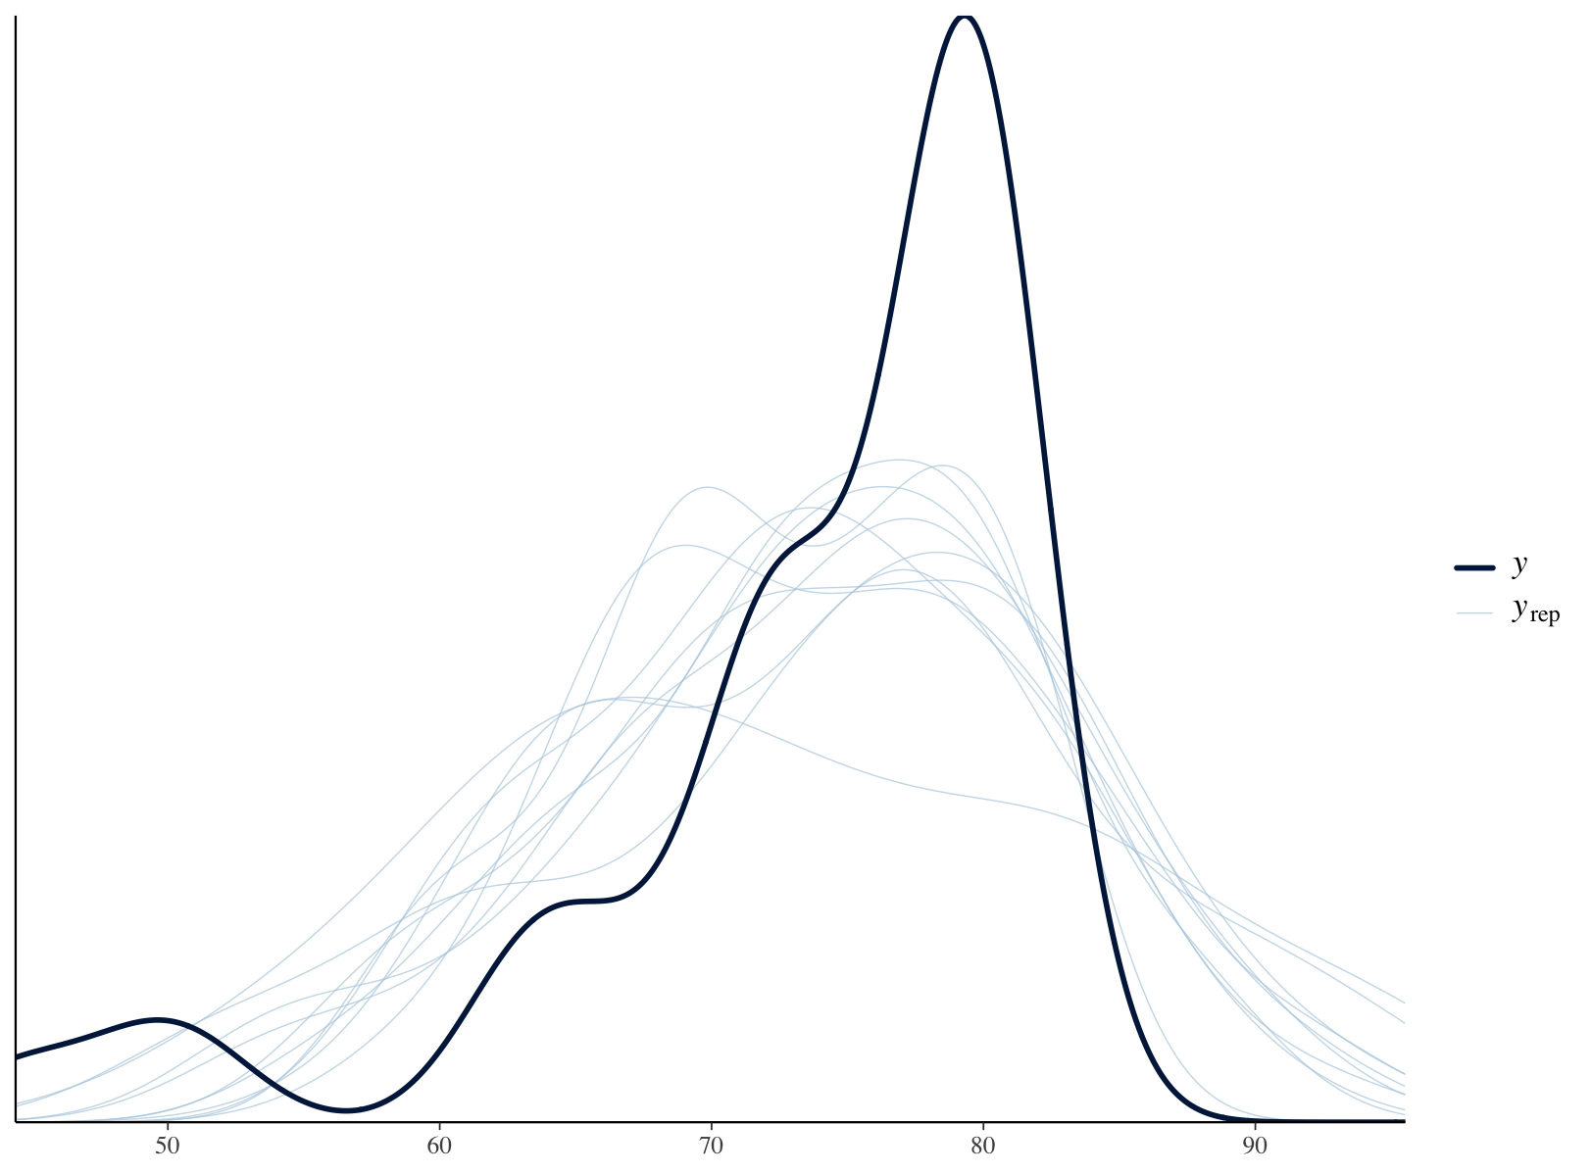
This plot is not looking so good. The $y_{rep}$ curves are not aligning well with the y curve. The issue here is likely a small sample size and some pretty extreme outliers.
- Now again consider the USTempLocation.csv dataset from Practice 2.
  - Read in the dataset, change CitySize to a factor with the levels "Under1M" and "Over1M" like you did in Practice 2, and then fit a logistic regression model predicting CitySize from JanTemp and Region. Write down the model here.
$$logit\left(\hat{π}\left(x\right)\right)=-4.46+0.110\left(JanTemp\right)+0.621\left(Northeast\right) \\ -2.44\left(South\right)-0.475(West)$$
  - Now fit a Bayesian logistic regression model using brm() with family = bernoulli() with the default priors and using "cmdstandr" as the backend. Write down this model.
$$logit\left(\hat{π}\left(x\right)\right)=-5.05+0.12\left(JanTemp\right)+0.77\left(Northeast\right) \\ -2.56\left(South\right)-0.46(West)$$While not all that different from the logistic model, the estimates changes a little more than they did in the linear regression model in problem 1.
  - In the logistic regression model, only JanTemp (and the intercept) was considered significant since its p-value was less than 0.05. For Bayesian models, we can tell which variables are significant based on whether zero is in the Bayesian credible interval or not. If both bounds are positive or both negative, then the variable is significant. If one bound is positive and one is negative, then it is not significant. Based on the l-95% CI and u-95% CI values in the output, which variables are considered significant in the Bayesian model?
The 95% credible interval for the intercept is $-8.61<true intercept<-2.34$ and the 95% credible interval for the slope of JanTemp is $0.03<true slope<0.23$. These are the only two parameters that are significant. Each of the others has 0 in the interval.
  - Now set the following priors:
For JanTemp: normal with mean 1 and SD 1.
For RegionNortheast: normal with mean 2 and SD 1.
For RegionSouth: normal with mean -2 and SD 1.
For RegionWest: normal with mean 0 and SD 1.
Then fit a Bayesian model with "cmdstanr" backend, 4000 iterations, 6 chains, 4 cores, and a seed of 1. Type ?brm in the R console for more info on how to set iterations, chains, cores, and the seed. Setting the cores to 4 will run 4 chains at the same time in parallel across different cores on your computer.
Looking at the output of the new model, which variables are now considered significant?
With these priors, the model is now
$$logit\left(\hat{π}\left(x\right)\right)=-5.29+0.12\left(JanTemp\right)+1.53\left(Northeast\right) \\ -1.96\left(South\right)+0.06(West)$$
Now the intercept, the slope of JanTemp, and the slope of regionNortheast are significantly different from zero.

  - The predict() function also works with Bayesian models. However, it gives more information than for a linear or logistic model. The predict estimates are in the first column of the output of predict(). So, you could type predict(bayesian_model)[,1] to get the predictions. Produce a table with all the actual and all the predicted values from the model with the custom priors you fit in part (d) using 0.50 as the probability cutoff for predicted the city has over 1 million people. What percent of cities were classified correctly?
The results here are exactly the same as the results from the logistic model in practice 2.
prediction
truth 0 1
Under1M 48 1
Over1M 6 1
The percent of correctly classified cities is $\frac{48+1}{48+6+1+1}⋅100\%=\frac{49}{56}⋅100\%=87.5\%$. While that is a good percentage, it is misleading. There are far fewer cities with a population under 1 million in the dataset than there are over 1 million. So while the overall accuracy is pretty good here, our model only predicted 2 cities as having a population over 1 million and only one of those was correct. There are other measures we will consider later of how to evaluate a logistic regression model’s performance.

The predictions do get different if we use a cutoff other than 0.50, though.
  - Use the pp_check() function on this Bayesian model with the custom priors and comment on it.
The graph is shown on the next page. While there is some variability in the replicated curves, the true y curve falls right in between them, so this indicates this model is fit well.
